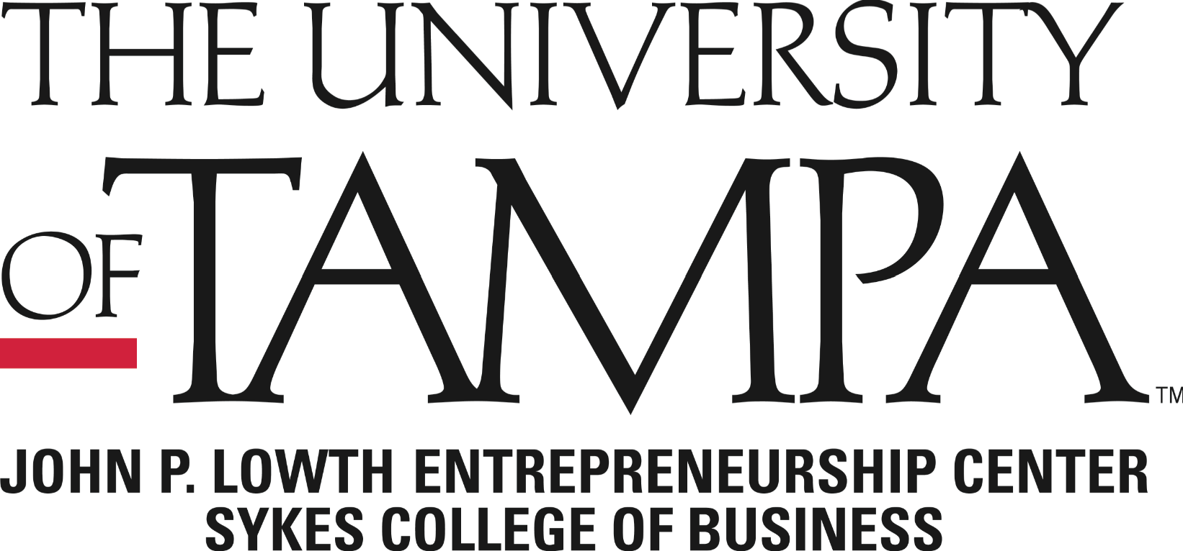
The University of Tampa Spartan Accelerator Application Form
2018-2019
The Spartan Accelerator was established to assist early-stage ventures of University of Tampa students. Its services range from business coaching/mentoring to professional, educational, and capital resources that can assist you with growing your business. Please answer the following questions (and provide the requested information) so your application can be evaluated and the appropriate support package can be developed to meet your needs.
Company name:
Contact:
Title:
Address:

Phone: Fax:
Email: Website:
Are you a current student The University of Tampa? (circle response): YES NO
If answered yes above, what is your graduation year and major?

GENERAL DESCRIPTION OF BUSINESS
Provide as detailed information as you have for these sections. It is perfectly fine to say this does not apply or that this is an area of need for your business. Attach extra sheets or business plan if necessary. However, please do not write “See business plan.”)

Please tell us about your business:

Is this a new business or a sub-division with an established business?

Do you have Intellectual Property?

How has IP been generated, and what are your future plans for further R&D on the IP?

Does your business require any governmental or regulatory approvals?

Describe management and technological expertise of your key personnel, experience that relates to your product/services, and the length of that experience (attach resume).

Description of products/services to be offered:

What unmet market need or demand does your product/services fulfill?

Details of your potential customers:

Details of market research activities for the product/service that have been produced:

Details of major competitors:

What are your competitive advantages?

Describe your pricing strategy:

How will you promote/advertise your products/services?

How will you distribute your products?

Who are your major suppliers?

What sales volume is needed to break even and in what timeframe?

How long have you been in the business?

Are you pursuing this business on a: Full-Time Basis or Part-Time Basis

How many people (including yourself) are working in the business?

At what stage of development are the products or services you wish to market through your business?
Pre-Concept Stage Saleable Products/Services Stage
Concept Stage Other (Please specify)
Prototype Stage

Do you have a completed business plan for this venture? Yes No

Note: If you have a business plan or a concept document for this business please submit with your application

Do you have a management team established for this venture? Yes No
If yes, which areas of expertise does the management team possess?
Prior experience with the product or service being developed by the venture
Technical expertise necessary to develop the product/service
Small business management expertise
Operations Accounting Finance
Marketing/Sales experience in the industry (or related industry) in which the
product or service is to be sold
Prior experience in raising capital for a new venture
Please identify the industry sector or sectors that would be characterize your business:

Please provide a brief description of your challenges or needs (50 words or less). If you are unsure, say “unsure.”

What are the critical business objectives for the next three (3) months?

In general terms, what are the business goals for year one?

In general terms, what are the business goals for year two?

Approximately how much space (offices, lab, manufacturing space, special requirements, etc) do you require now?

How many total employees will be occupying the space? : Full-Time Part-Time
Infrastructure requirements for space, cubicles, other furniture, or PCs:

If accepted in the accelerator, when would you like to begin occupancy?

Please identify the type(s) of assistance you are seeking (please check both the area to the right of the topic and the urgency of your need):

 |  | Very Urgent | Somewhat Urgent | Not Urgent
 | General Business Assistance
 | Market Research
 | Marketing/Sales – Domestic
 | Marketing/Sales – International
 | Business Plan Preparation
 | Legal Services:
 | Intellectual Property Support
 | Contract Development
 | Corporate Formation
 | International (import/export)
 | Accounting Services
 | Financial Services
 | Management Team Development
 | Product Development
 | Manufacturing/Production Services
 | Financing (Debt)
 | Financing (Equity)

Other Needs – Please explain:

How did you hear about the Spartan Accelerator?

Please tell us a little about yourself (attach a current resume):

DECLARATION

I declare that to the best of my knowledge the information I have provided on this form is correct and that I have not omitted any facts that may have a bearing on my application. I understand that falsification of qualifications or information may lead to dismissal of my application.

Signature: Date:

Name (print): Title:

Spartan Accelerator Milestones 2018-2019
Name:
Business Name:
Please Circle the Milestones You’d Like to Achieve in  Your Business in the  Upcoming Year: | Legal (file for LLC/ incorporate your business/ etc.)
 | Building Your Brand with Social Media
 | Sales (goals/training)
 | Building a Team
 | Business Modeling/Planning
 | Creating a Network
 | Developing Persistence & Entrepreneurial Mindset
 | Financial Literacy (personal and/or business)
 | Raising Capital
 | Business Tax
 | Design Thinking
 | Mastering Your Pitch
 | Intellectual Property: Patents, Trademarks, Copyrights
 | Product Development
 | Other milestones you want to work on not mentioned:
Spartan Accelerator Participant Agreement 2018-2019
Participant Name: _______________________________________________
Signature: _____________________________________________________
Date: _________________________________________
I understand that I will be a Spartan Accelerator participant at The University of Tampa and will be unpaid for my time. I also understand that I will not be considered as an employee of The University of Tampa for any reason. I agree to comply with all UT policies regarding participation in the Spartan Accelerator Program, and regarding the use of UT facilities.
Requirements:
- I will attend and participate in the weekly mandatory 90 minute meetings.
- I will be open to graduate and undergraduate students help me with my business, helping students with their businesses, and supporting faculty in their requests for involvement of student and class projects.
- I agree to share data and information about my business to the Sykes College of Business’ Lowth Entrepreneurship Center at the University of Tampa for the next 5 years after Incubator program completion.
- I agree to participate in Lowth Entrepreneurship Center events, and any other activities that allow me to network with the community.
- I understand that failure to comply with these requirements will jeopardize my ability to stay in the Spartan Accelerator Program, as I will be evaluated on a semi-annual basis.
I , for myself, my heirs, executors and administrators, waive and release any and all rights and claims for my damages I may have against The University of Tampa and its agents, employees and contractors and their representatives and any and all claims of damages, demands, actions whatsoever in any manner, as a result of my participation in the Spartan Incubator program at The University of Tampa. I hereby release those parties from any and all claims, including those claims arising from their own negligence or the negligence of any one of them. I have read the above release and I understand and agree to the terms. I understand that I will be required to consent to a criminal background check as a condition of participation in the Spartan Accelerator Program.
Signature: Date:

Name (print): Title:

